**Clinic Database Schema**

**we will use 3 tables to design this system:**

* **Patients**
* **Doctors**
* **Medical History**
* **Appointments**
* **prescriptions**

**the ER diagram of the system:**

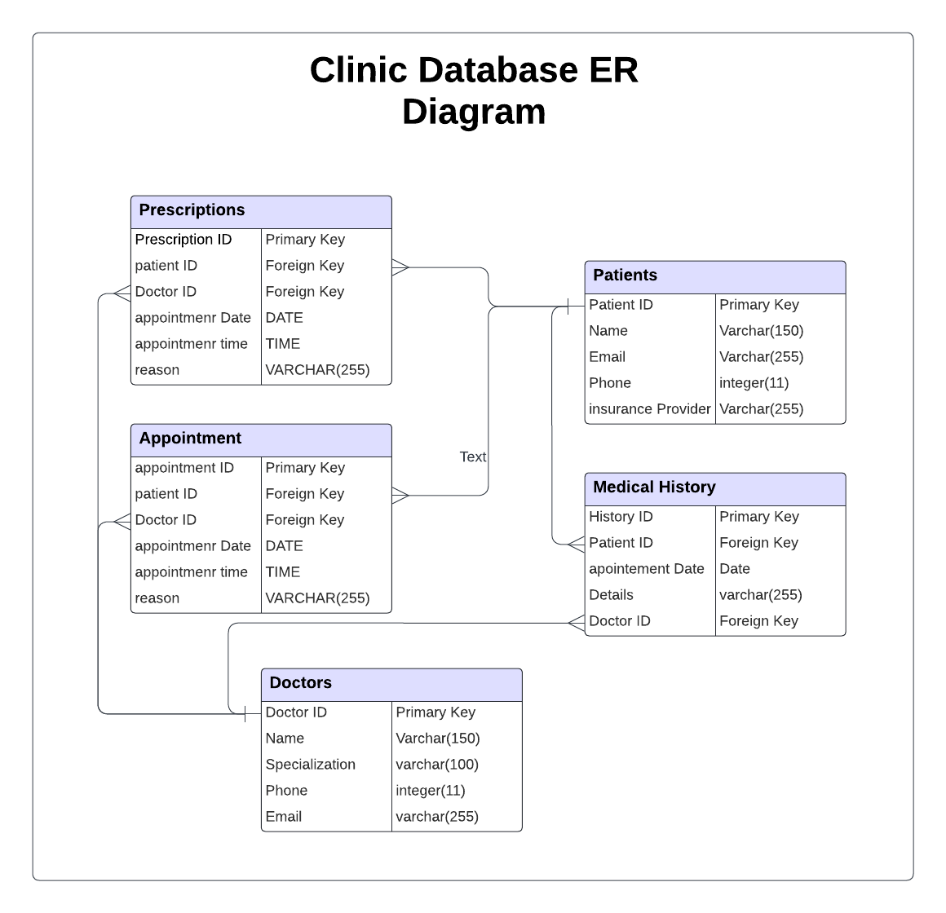

**SQL code to Create the table:**

**Code Highlighter**

[**https://ray.so/**](https://ray.so/)

